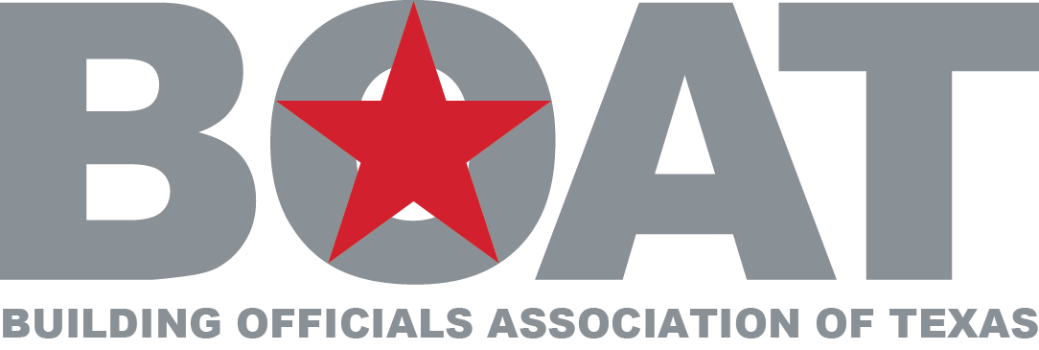

Building Officials Association of Texas
Board of Directors Meeting Minutes
Waco Hilton
February 5, 2013
10 a.m.

PRESIDING: President - Lawrence Crow

PRESENT: Directors at Large: Bruce Braley, Mike Olsen, Earl Abbott, Selso Mata and Van Tran (Associate Director at Large). Immediate Past President – Scott McDonald, Second Past President – Randall Childers, TML Board Representative – Jim Olk

CALL TO ORDER:
President Lawrence Crow called the meeting to order at 10:08

- APPROVAL OF MINUTES:
President Lawrence Crow indicated Mr. Chris Haver would email the Minutes of the November 15, 2012 at a later date for all to review and approve.

- FINANCIAL REPORT:
President Lawrence Crow reported a full financial report was not available due to TML representative turnovers, however last December BOAT was $52,000 in the black pending BPI expenses.

- TML UPDATE: 100 YEAR ANNIVERSARY:
Discuss BOAT Involvement and Results: Jim Olk reported we had great representation at the BOAT booth. Mr. Olk suggested creating a pool of retired building officials to aid cities during vacancies similar to other professions such as city managers, city attorneys, etc. Mr. Olk reported the sign association expressed desire to work with building officials to improve ordinances related to their industry. Mr. Olk reported we gained about 20 members during the conference.

Future Opportunities / Affiliate Coordinator (Lawrence): Mr. Olk suggested a mandatory training day with TML for new BOAT directors and creating a bridge between all 21 TML affiliates. This would help new directors to improve leadership abilities and increase the impact of the value of building codes. Mr. Olk reported council members like to hear from industry experts. President Lawrence Crow ask Jim Olk to lead in the creation of training program presentation for future TML Conferences.

- COMMITTEE UPDATES:

- Awards and Scholarships: Selso Mata gave feedback regarding the last awards presentation. He felt the scholarship application went from complicated to relaxed. He recommended adding back certain qualifications and merits and would review Utah’s model. President Lawrence Crow asked Mr. Mata to contact Ray Burgess for best ideas and to lead a group to find best model for the application. A motion was made by Scott McDonald and a second by Randy Childers. All approved

- Building Professional Institute (BPI): President Lawrence Crow noted that Kurt Kasson was out of state. It is estimated that 500 plus are attending the Houston BPI. Mr. Lawrence reports it’s the number of classroom days that gauges success for the program. An additional $10 per day was added to improve the BOAT profit margin. Mr. Lawrence reported that John Brown was helping improve attendance for the Houston class. Mr. Lawrence also reported the BPI banner was being updated to include a stronger BOAT appearance and he was looking into ways to improve leveling instructor fees and costs. Future meetings will be held with Dr. Mathis, Ravi Shan and Mr. Lawrence to review best methods to improve costs.

- Code Development: Mike Olsen said he would be working with Jim Olk and Scott McDonald for a future report.

- Membership, Promotion and Development: President Lawrence Crow reports Chris Haver is working to improve membership. Contacts have been made to building officials for Midland, Odessa, Corpus Christi, Austin, etc., plus recently with the Bluebonnet and Lone Star Chapters. Scott McDonald suggested reconnecting with Texas cities to drum membership. Mr. Crow stated the East Texas Chapter in Terrell has been created.

- Legislative: Jim Olk reports he sent email updates a while back to the directors. There are not too many issues for inspectors. HB 403 is the Good Samaritan bill; HB 578 is designed to prohibit the state from opening a case against buildings more than a year old; and HB 613 is related to licensing and regulating foundation repair companies.

- 2013 BOAT ANNUAL FALL CONFERENCE (WACO):

- Registration Fee: President Lawrence Crow reported the registration fee may go up from $195 to $275 but not to exceed $295.

- Exhibitor Fees: President Lawrence Crow asked Van Tran to review such fees and make recommendation back to the president.

- Sponsorships: President Lawrence requested board input for improving such fees.

- Hotel Space Layout and Tentative Program: President Lawrence Crow, Randy Childers and Scott McDonald indicated they would visit with the hotel to review best savings for the hotel contract.

- SCHEDULE OF UPCOMING MEETINGS & LOCATIONS:

- BPI Arlington (May 20-24, 2013): President Lawrence Crow reports Kurt Kasson will have more information later. The goal is to improve attendance from 1,400 to 1,600 students. A Board meeting is scheduled May 22 and the Business meeting is May 23 at noon.

- BOAT Conference (August 6-9. 2012) [Waco]: Mike Olsen reported he is working on final plans for a skeet shot event. Both the Bluebonnet and Lone Star Chapters have committed funds to support this event.

- Capitol Area BPI (Tentatively October 7-9, 201): President Lawrence Crow reports the Capitol Area Chapter is committing a minimum of 200 people for the conference. Mike Olsen reported the Bluebonnet and Lone Star Chapters have donated their ½ day ICC free training class days to this event.

- November 2013: Item to be discussed later.

- NEWS LETTER:
President Lawrence Crow reports only Mike, Randy and Earl have turned in their articles. He reminded members of the importance to turn in your articles for the news letter.

- ICC/DALLAS CODE HEARINGS & REGION X UPDATE:
President Lawrence Crow reminded everyone of the April 21-30, 2013 event for the review of the minor codes and the Region X meeting on Friday. All attending should bring Arlington BPI Handouts. He asks for a good showing.

- OTHER BUSINESS:
- Texas Town & Country Magazine Advertizing: Randy Childers asked if the Board was interesting in spending $550 for an advertisement in the back of the magazine. After some discussion, President Lawrence Crow recommended to discuss and vote on this in May.

- Rangers Tickets (May 21): Randy Childers asked the board if they were interested in purchasing up to 20 tickets at $34 each for “all you can eat” seats. Half the tickets are for the Board members and the other half will sell. Mike Olsen made a motion to purchase the tickets as noted and Bruce Braley seconded the motion. All approved.

- ICC Board Candidate: Van Tran and the board members in attendance encouraged Scott McDonald to run for office and give support to Ravi Shah.

10. ADJOURNMENT:
There being no further business, the meeting was adjourned at 1:45PM.

Building Official Association of Texas
Board of Directors Meeting Minutes
Waco Hilton
August 7, 2013
7:00 pm

PRESIDING: President Lawrence Crow

PRESENT:
Mike Olsen, Bruce Braley, Jim Olk, Kurt Kasson, Randall Childers, Scott McDonald, Earl Abbott, Jim Olk, Van Tran, Chris Haver, Hamid Nadir, Mark Roberts

CALL TO ORDER:
President Lawrence Crow called meeting to order at 7:05 pm

- FINANCIAL REPORT:
President Crow reported the conference would profit close to $3000, TML contract would be increasing by 47%, he gave an update on BPI Arlington expenses and said that there was a profit of $40,292, and Austin BPI needs 175 students to break even. Lawrence discussed increasing stipend for Clawson and Matthys. Scott McDonald made a motion to increase stipend from $7000 to $10000. Mike Olsen seconded the motion, motion passed (10-0).

- VETTING QUESTIONS:
The group decided we would not be sending any letters for the ICC candidates and no vetting questions this year.

- BUSINESS MEETING AUGUST 8, 2014:
Board discussed the BOAT annual conference for 2014. Van Tran and Lauren Grossman will work on fees and sponsorship. Mike Olsen will help plan the Grapevine conference. Lauren asked that the programming be turned in by February so she could get it on the website. Bruce Braley made a motion to have a four-day conference starting at 12:00 pm on Tuesday through Friday. Mike Olsen seconded the motion, motion passed (10-0).

- DISASTER ASSISTANCE:
Jim Olk discussed purchasing trailers and placing them around the State in preparation for emergency events. Jim Olk, Bruce Braley and Mike Olsen will put together a plan and move forward with momentum from recent events. They will also look for sponsors to help with trailer costs.

- PUBLISHING:
Hamid Nadir and Jim Olk discussed BOAT and ICC working together on Dangerous Building Code. They will come back to the Board with price and contract.

- KENYA WATER WELL:
Mike Olsen made a motion to donate $500 to drill a water well in Kenya. Randy Childers seconded the motion, motion passed (10-0).

- SECTION 907 of the INTERNATIONAL RESIDENTIAL CODE:
The Board had concerns about the language in this section. Jim Olk, Scott McDonald, and Lawrence Crow will draft a letter and take forward to ICC.

- ADJOUNMENT:
There being no further business, the meeting was adjourned at 10:24 pm.

Submitted by Chris Haver.

