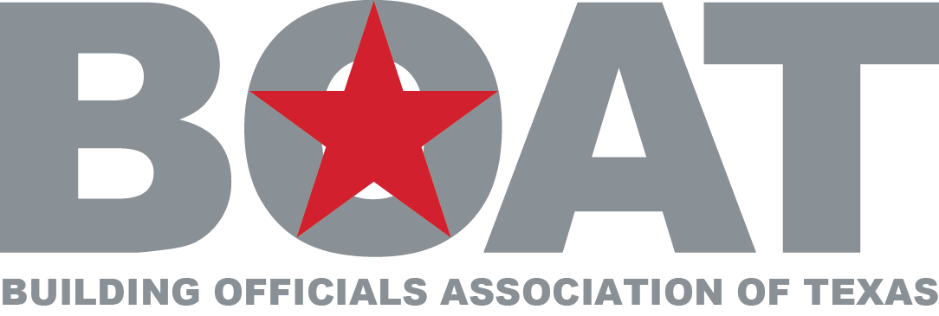

Board Meeting Minutes
Arlington BPI
May 21, 2015

Presiding: Kurt Kasson President

Present: Mike Olson, Lawrence Crow, Jim Olk, Sean Smith, Cyndi Lewis, Penny Peterson,.

Call To Order:
President Kurt Kasson called the meeting to order at 9:42 AM. Secretary confirmed a Quorum had been met.

- Approval of Minutes
Motion made by Jim Olk to approve the minutes as presented from the February 2015 Board Seconded by Lawrence Crow. Motion carried 5-0

- Financial Report
Mike Olson gave update of Financials. April 2015 report shows 45,502.57 in account. Financial statement does not show Houston reimbursement.

- Planning of 2015 Annual Meeting in Texarkana
It was discussed about paying for the registration and hotel for all Board members for 3 room nights. Motion made by Lawrence Crow and seconded by Jim Olk to pay the registration and 3 room nights for each Board member. Motion Carried 5-0

Lunch on Wednesday at the Annual conference will allow the presenting sponsor Smartvent to speak from 11:45-12:10 and our guest speaker Todd DeWitt will speak from 12:15- 1:00.

Was mentioned that a layout for vendors at Sugarland will need to be available for the Board at Texarkana to allow vendors to choose their space for the next year as long as they pre pay for spot.

- Board Member Updates

Kurt informed Board that they would be given sections of the employee handbook to review so that we may discuss at a later date.

- Adjournment

Meeting was adjourned at 11:15 PM.

Submitted by: Mike Olson

Business Meeting Minutes
Arlington BPI
May 21, 2015

Presiding: Kurt Kasson President

Present: Mike Olson, Lawrence Crow, Jim Olk, Sean Smith, Cyndi Lewis, Penny Peterson, Keith Smith.

- Opening Meeting/Check For Quorum
President Kurt Kasson called the meeting to order at 11:41 AM. Secretary confirmed a Quorum had been met.

- Approval of Minutes
Minutes will be reviewed at annual business meeting.

- Financial Report
Mike Olson gave update of Financials. April 2015 report shows 45,502.57 in account. Financial statement does not show Houston reimbursement.

- Go Over Agenda For Texarkana
President Kasson gave an update on the Texarkana Conference and Cirriculum. Invited everyone to attend and let them know we were basing it towards the Building Official and not the Inspector.

- Board Member Updates
None at this time.

- 2016 Annual Business Meeting Sugarland Locked Down
President Kasson gave a speech on where the 2016 Conference will be and an idea of what was in store.

- Other Business

Kurt Kasson gave an update on all the BPI’s that BOAT is putting on. Jim Olk gave an update on Disaster Response and how they helped in Van,Tx where a tornado touched down.

- Adjournment

Meeting was adjourned at 12:32 PM.

Submitted by: Mike Olson

